Come to Uganda with Bishop Jan!
January 20 – 30, 2020
Africa is a wonderful place to visit. If you think you know Africa based on old Tarzan movies, you are in for an exciting awakening! Sub-Sahara Africa retains much of its old charm and culture while the cities and infrastructure are rapidly developing. Bishop Jan L. Beaderstadt, president of Renaissance Outreach Ministries is leading a wonderful Eleven Day Tour, January 20 - 30, 2020. This tour will not only feature the most exciting places of the peaceful East African nation of Uganda, but also an opportunity to meet the people and see the missions where he works.
Highlights Include:
- Lake Victoria – Africa’s largest freshwater lake and second largest freshwater lake in the world
- Queen Elizabeth National Park – Look for tree climbing lions and see incredible African animals in Africa’s premier safari national park.
- Kazinga Channel – Boat trip down the channel to see great views of African Animals.
- Rwenzori Mountains – Highest Mountain Range in Africa
- Visiting various mission places including Rwenzori School of Nursing & Midwifery and Bethel Christian School
This trip includes:
- Three Star Hotels, similar to a Best Western Hotel in USA.
- Breakfast every day
- Meals as noted
- Welcome and Departure Dinner in Kampala
- Cruise on Kazinga Channel in Queen Elizabeth National Park
- Entrance fees to Queen Elizabeth National Park
- English speaking guide
- Mukanzo Cultural Program

Detailed Itinerary – Day by Day

DAY 1 –MONDAY, JANUARY 20, 2019 - DEPARTURE FROM USA
Leave from Bishop Airport in Flint, Michigan as you travel to Uganda. It takes three flights to reach Uganda as we fly from Flint to Qatar which is a brand new airport on Qatar Air. Board the final flight to Entebbe, the gateway to Uganda on the shores of Lake Victoria.

DAY 2 – TUESDAY, JANUARY 21 - ARRIVAL IN UGANDA
We arrive in Entebbe, Uganda, the gateway to East Africa. The flight has gone over the Sahara Desert now to the green of East Africa below. Entebbe is on the northern shores of Lake Victoria where we land. We pass through passport control and once through, we meet our guide as we board our vehicle. We will take an hour journey to the
Bishop Jan L. Beaderstadt
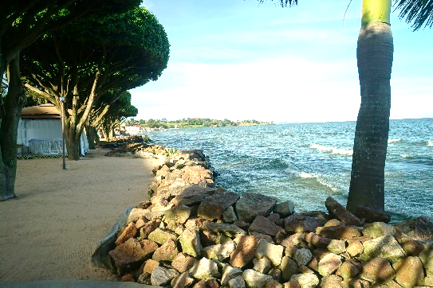
Lake Victoria, the second largest freshwater lake in the world.
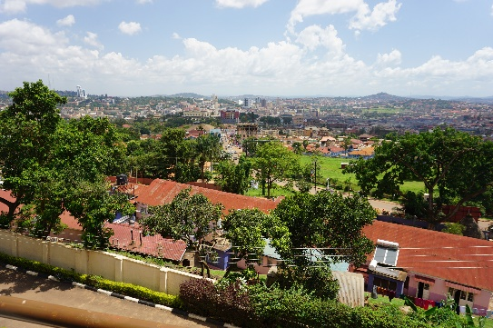
Kampala, the capital of Uganda
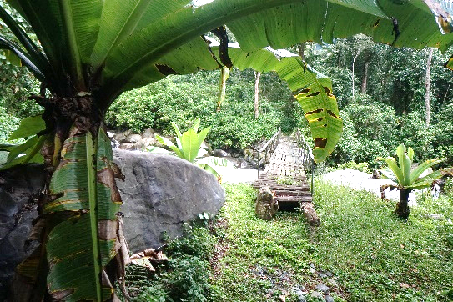
Rwenzori Mountains
Only $2495
Per Person, including airfare!

modern capital city of Kampala where we will stay at Namirembe Guest House, known for its million-dollar view of the city! Enjoy a welcome dinner in the evening. Included today is the welcome dinner.

DAY 3 – WEDNESDAY, JANUARY 22 - TRAVEL TO LAKE NABUGABO
Your body needs a day to adjust for jet lag and the time zone difference (it’s 7 hours between Eastern Africa Time and Eastern Time Zone). One of the best places to chill out and rest is at the beautiful resort on Lake Nabugabo We stay in cottages with wonderful facilities and great food (all meals included). Rest, go swimming in the lake (no crocodiles or hippos in this warm water lake with a wonderful sandy beach!). There’s even an optional boat ride to view the lake. In the evening, enjoy a great dinner overlooking the water. At night, enjoy the quiet jungle sounds as you drift off to sleep. Included: all meals.

DAY 4 – THURSDAY, JANUARY 23 - TRAVEL TO LAKE MBURO NATIONAL PARK. LODGE IN MBARARA – We rise early for breakfast and then travel to just outside of Lake Mburo National Park. This is the best place to see zebras and impalas, and you will definitely see them here. We cruise through the jungle in our vehicle, taking pictures of the jungle animals. This park is home to a small population of giraffes. We may not see giraffes here, but we will see zebras and impalas, which are graceful animals. At night, we stay at Uganda’s 4th largest city of Mbarara. Included: breakfast and box lunch.

DAY 5 – FRIDAY, JANUARY 24 - CHIMP TRACKING AND KASESE
Western Uganda features several great places to look for chimpanzees, and we’ll be stopping at Kalinzu Forest where we will do some chimp tracking. Today is the day we walk the longest, most likely around 2 hours to go in and out of the jungle. We sit and watch the chimps as they come in families to look at you. There is a 90% chance of seeing chimpanzees as we travel with our chimp guide. From here, travel through Queen Elizabeth National Park where we will see plenty of animals along the way. We may even see elephants in the wild. Our destination is the city of Kasese, the Gem of the Pearl of Africa. We will spend several nights here in Kasese as we see the sights that western Uganda has to offer. Included: chimp tracking and breakfast.

DAY 6 – SATURDAY, JANUARY 25 - QUEEN ELIZABETH NATIONAL PARK, KAZINGA CHANNEL BOAT TRIP
Queen Elizabeth is the premier safari park in Africa. A very large park, it is home of a great variety of African animals. While there are no giraffes, zebras or rhinos here, it is home to lions, water buffalo and herds of African elephants. We will travel into the park, following trails looking for animals. Our day starts early as many animals are up early before hiding in the jungle during the heat of the day. In the afternoon, we take a cruise down the Kazinga Channel which connects Lake George and Lake Edward. We’ll see elephants, hippos, crocodiles, hundreds of species of birds as well as water buffalo and other animals. Included: boat cruise, park admission, breakfast.

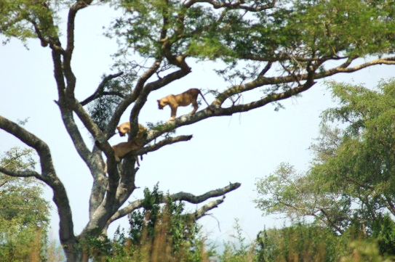
Tree Climbing Lions near the Ishasha Gate.
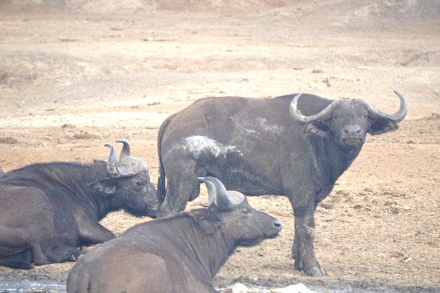
Water Buffalo
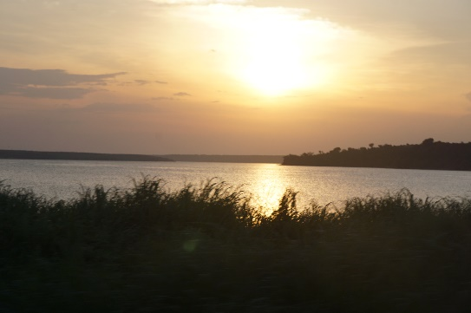
Kazinga Channel at Sunset
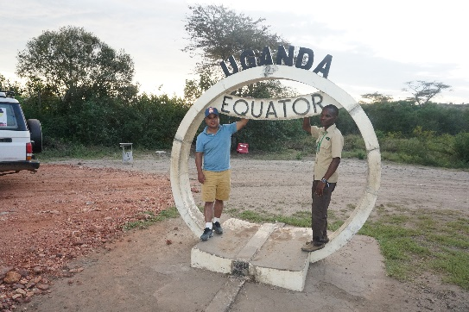
The Equator
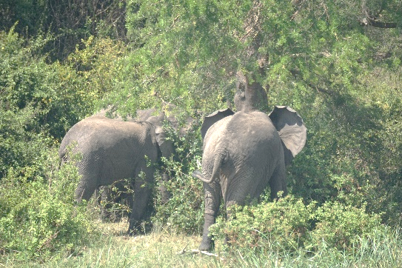
Elephants

DAY 7 – SUNDAY, JANUARY 26 – LION SAFARI AT ISHASHA GATE
Queen Elizabeth National Park is home to the only tree-climbing lions in all of Africa. The Ishasha Gate region is the best place to view them. While we have no guarantee of seeing these amazing cats, you will have an 80% chance of finding them in their natural habitat. Even if you don’t see lions, you will see plenty of other animals along the way. There will be a stop at a fishing village on Lake Edward, one of Africa’s largest freshwater lakes. It’s a full day’s adventure as we head into the wilds of the savannah. Included: breakfast.

DAY 8 – MONDAY, JANUARY 27 – TOUR OF MISSION SIGHTS
Today we journey to visit a number of mission locations. The day begins with worship service as well as a tour of the Rwenzori School of Nursing and Midwifery. From here, visit the Kikorongo Medical Outpost along with Bethany Christian School and Hosanna House which his a new school for physically challenged children for western Uganda. The school is unique as it’s the first of its kind in a rural area for Uganda. In the evening, enjoy a cultural program featuring traditional dancing of the Mukanzo tribe. Included: cultural program and breakfast.

DAY 9 – TUESDAY, JANUARY 28 – RETURN TO KAMPALA
It’s a day of travel as we leave Kasese and the western part of Uganda and travel back to the capital city. We pass from the Rwenzori Mountains into lush, green tea gardens. The land is hilly with some lakes as we make our way to Kampala. We return to the Namirembe Guest House where we enjoy our final night in the city and a departure dinner. Included: breakfast and dinner.

DAY 10 – WEDNESDAY, JANUARY 29 - DEPARTURE
It’s our final day in Uganda. After breakfast, we travel to Entebbe, past the beautiful blue waters of Lake Victoria to reach the airport where we fly back to USA. Included: breakfast

DAY 11 THURSDAY, JANUARY 30 – ARRIVAL IN USA
The end to an amazing adventure comes to a close today as we return to USA.

For More Information or to Reserve Your Place, contact
Bishop Jan L. Beaderstadt
Trekking Mart USA
207 W. Main Street
Turner, MI 48765
(989) 254-2175
Kathmandu & USA
jan@trekkingmart.com

www.trekkingmart.com

Special Information
- Visa – Uganda visa is available upon arrival in Entebbe. Cost is USD $50 (not included in price)
- Yellow Fever Shot – A yellow fever shot is required to enter Uganda. You should get this shot no later than three weeks before departure.
- Clothing – Uganda is located on the equator. January is sunny with temperatures in the mid to upper 80s and nights around 65. It rarely rains in January. Casual clothing is fine. Wear dark colors (no red) when in the jungle so you don’t scare away the animals. Definitely wear comfortable shoes.
- Walking – There is very little walking on this trip. The only day there is any walking is when we visit the Kalinzu Forest to look for chimpanzees.
- Malaria – Malaria is usually not a problem this time of year. However, we will have available for those who wish to purchase it anti-malaria medicine upon arrival.
- Insects – Unlike the movies, you will be surprised at how few insects you will actually encounter. Most people never even bother with bug spray. You are welcome to bring insect repellant, but probably not needed.
- Lodging – All of our places are three star quality that we use with mosquito netting, hot water and electricity.
- Food – We will enjoy western style food. Ugandans love bananas, peanuts, fresh vegetables and roasted meat. Food in Uganda is not spicy.
- Vehicles – We use 15 passenger Toyota Hiace Vans with no more than ten people per vehicle, giving you plenty of comfort in travel. We use vans because buses are not able to negotiate the narrow jungle roads in the national parks.
- Passport – You do need a valid passport with a minimum of six months left before expiration.

